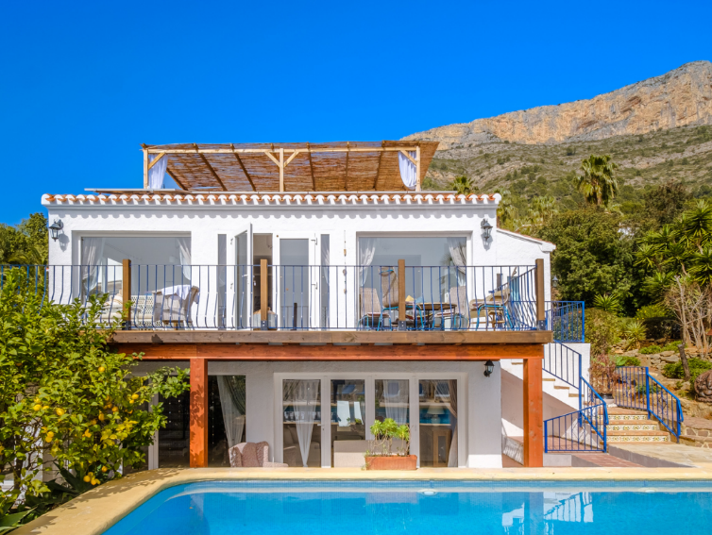

I am very excited to share the news that I will again be running a Yoga Retreat in Jávea, Costa Blanca, Spain 20-26 September 2026 and also 29 Sept – 5th Oct if demand is there.

The retreat will be held in a beautiful tranquil private Villa, with a stunning pool, poolside cabana, and peaceful yoga shala for our rooftop yoga sessions.

Alfresco dining with delicious vegetarian/vegan food, prepared lovingly by our own private chef.
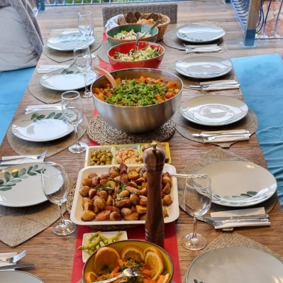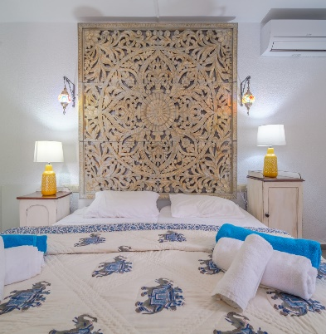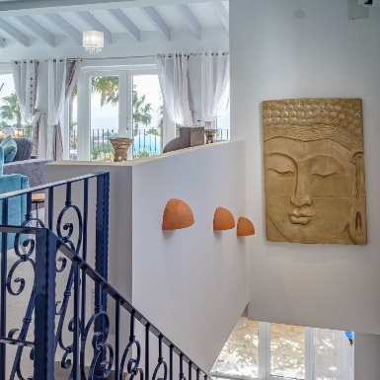

Early morning meditations
Morning 2- hour yoga sessions – Sunpower Flow (Energising)
Early evening - Restorative yoga & Yoga lifestyle (Relaxing)
Mantras, Chanting & Pranayama
Learn the basics of Ayurveda to improve health, wellbeing and overall happiness.
Sunrise yoga
Local market
1-day excursion
Connect your Mind, Body & Soul through the Ancient art of Yoga.

Stepping into a yoga retreat allows you to escape from your daily life and provides an opportunity to find peace and deep relaxation, healing both Mind and Body.

Everything in the daily schedule is optional, but I hope I am providing sessions you are keen to engage with. The Retreat is for YOU and I encourage you to listen to the needs of your body & mind each day to establish how much you participate.

There will be lots of free time to explore and enjoy the area and RELAX

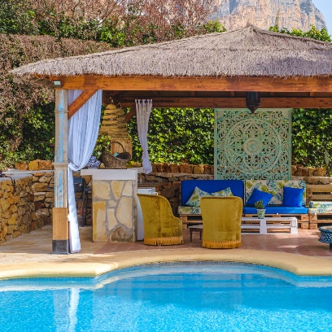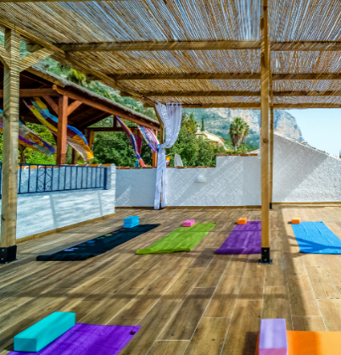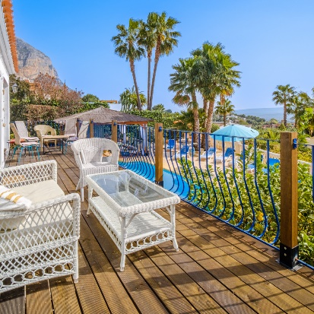

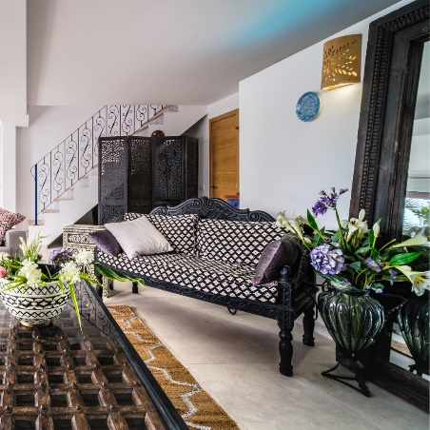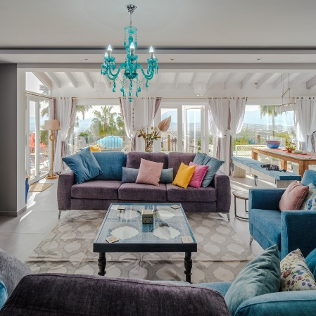

Cost: £950 pp (2 sharing)
+£350 single supplement if available
Flights NOT included
Transfers can be arranged
Deposit of £150 required to secure your place.

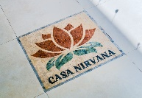
Contact Maureen to book your place or for more information
07507 636623
maureenthomson54@hotmail.com
www.loveyogalife.co.uk

